1. Create a new Process:

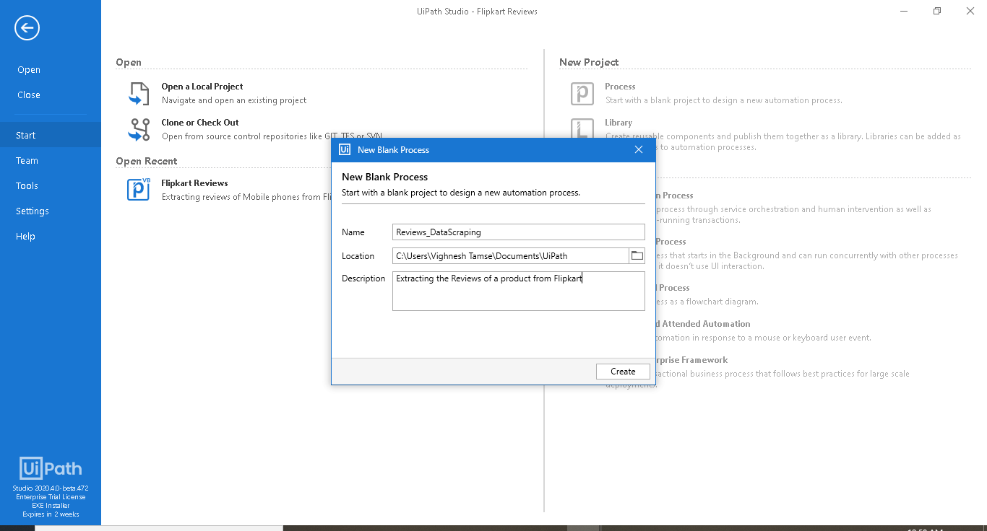

1. Create a new Flowchart: New 🡪 Flowchart

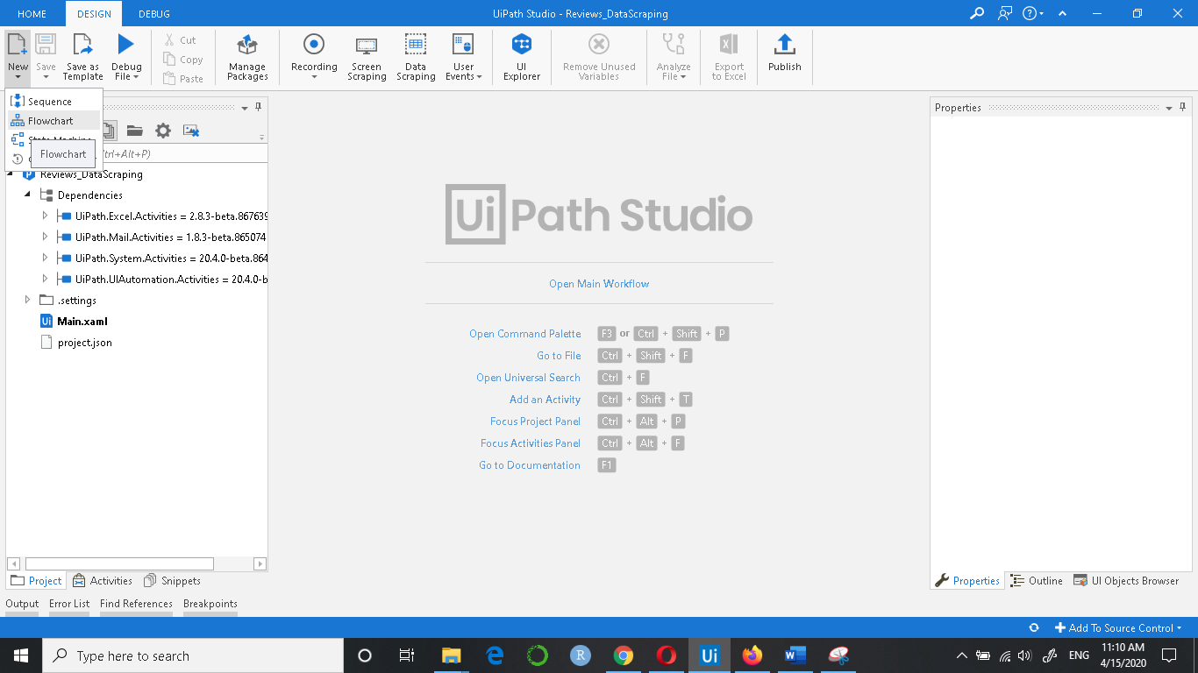

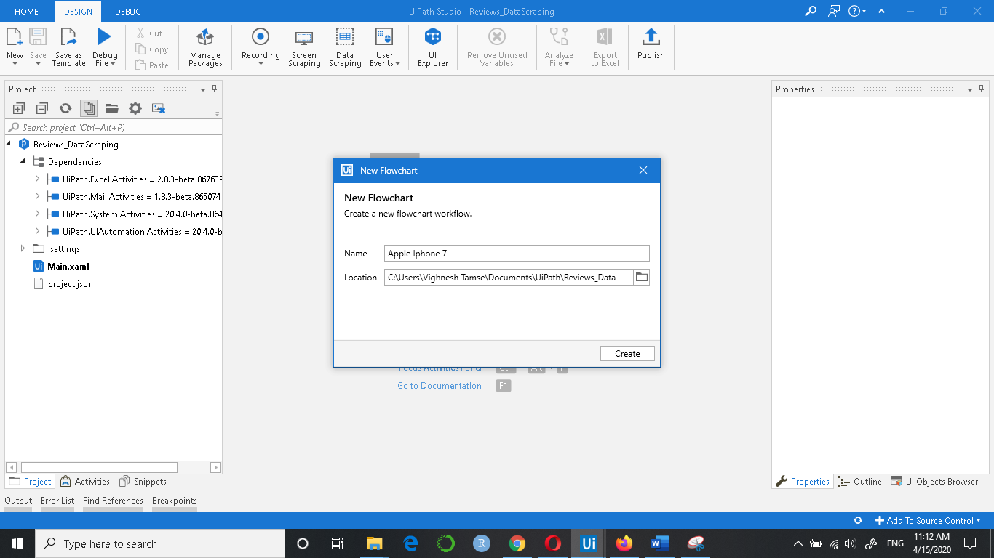

1. Click on the Activities tab on the bottom left, search Open Browser in the search box and drag and drop it below the Start.

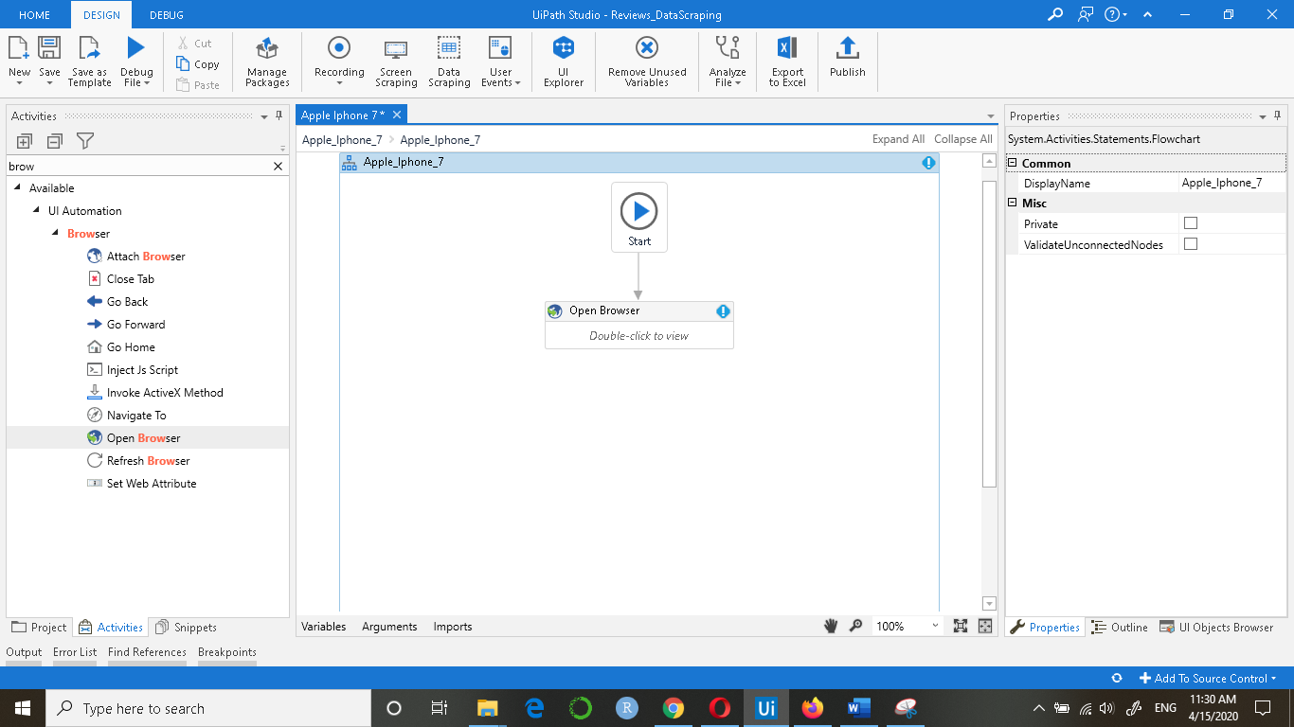

1. Double click on the Open Browser and enter the Review URL of the product

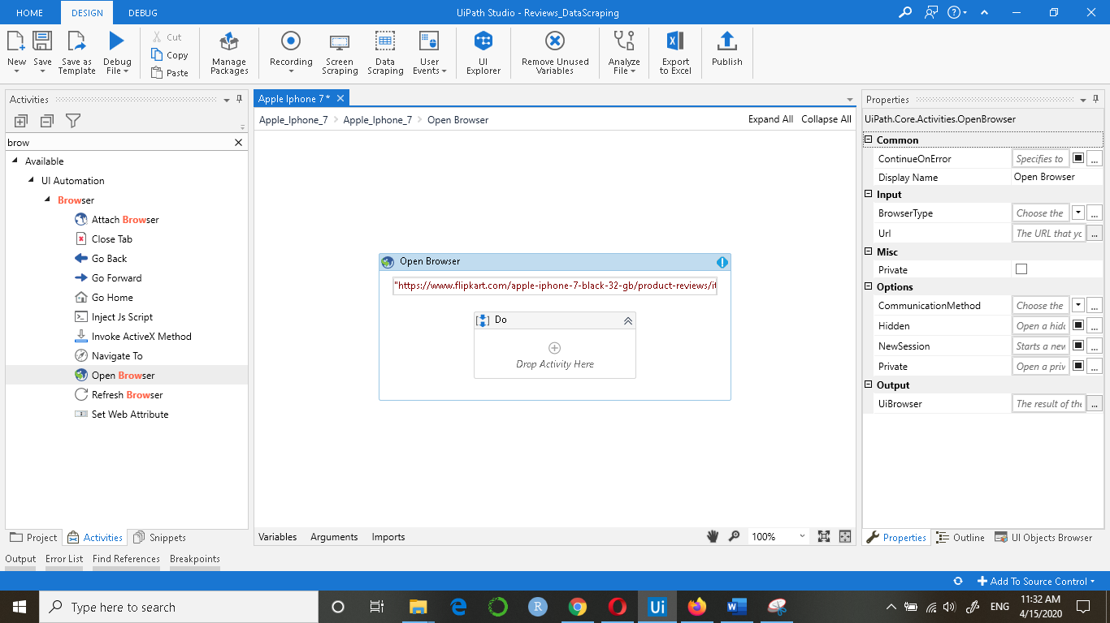

1. Click on the Data Scraping button on the top

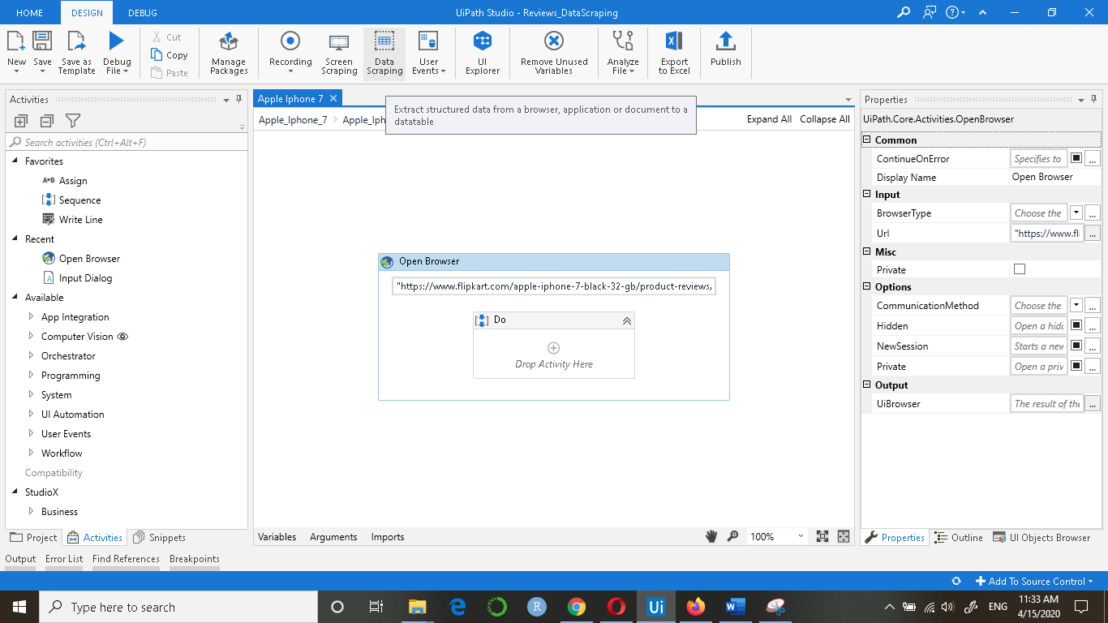

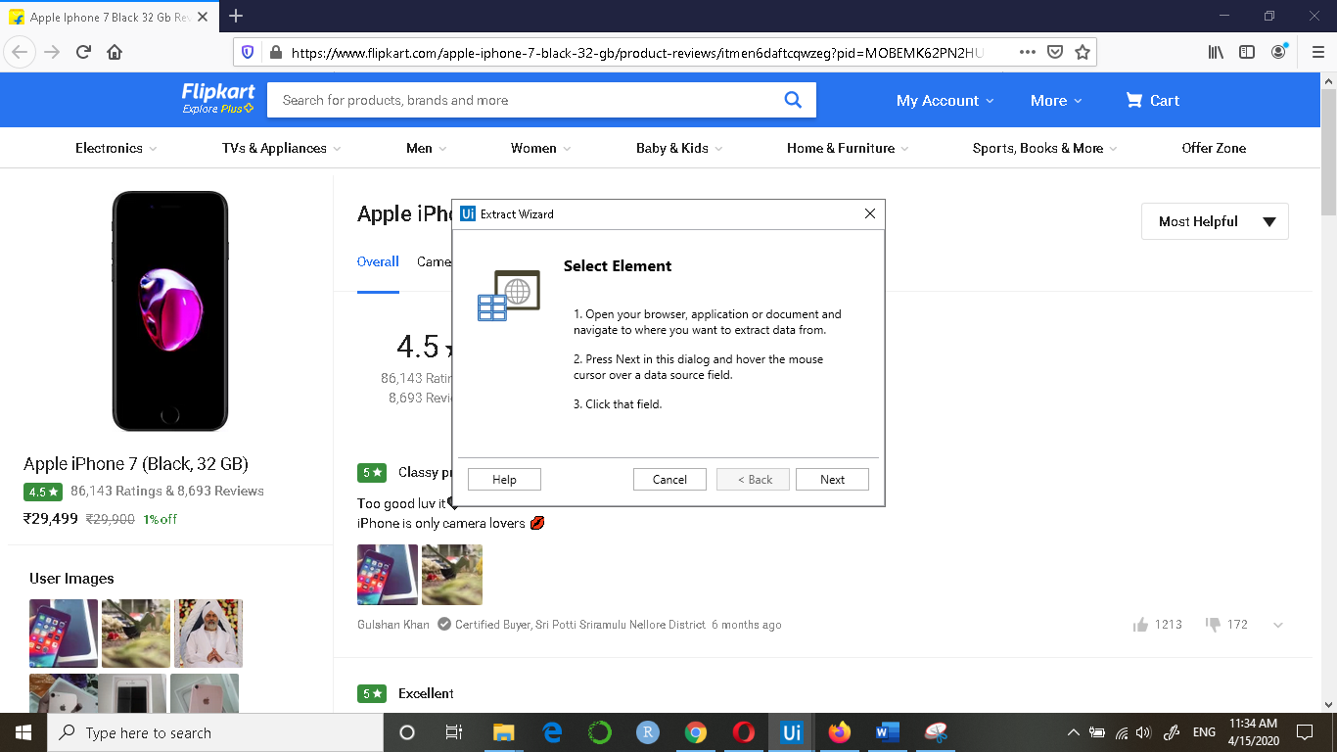

1. Click on Next and then click on Review Title

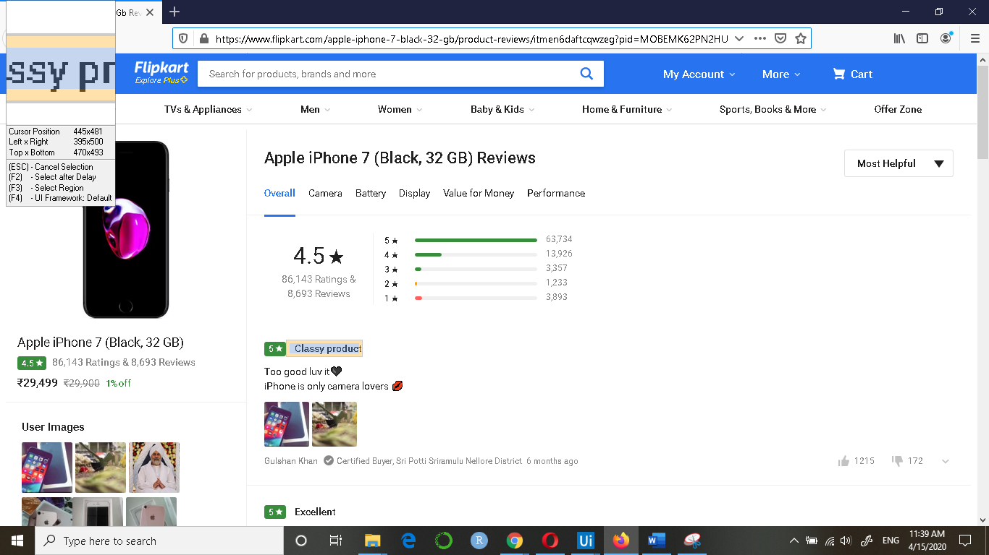

1. Now the click on the second review title when the following dialog box appears:

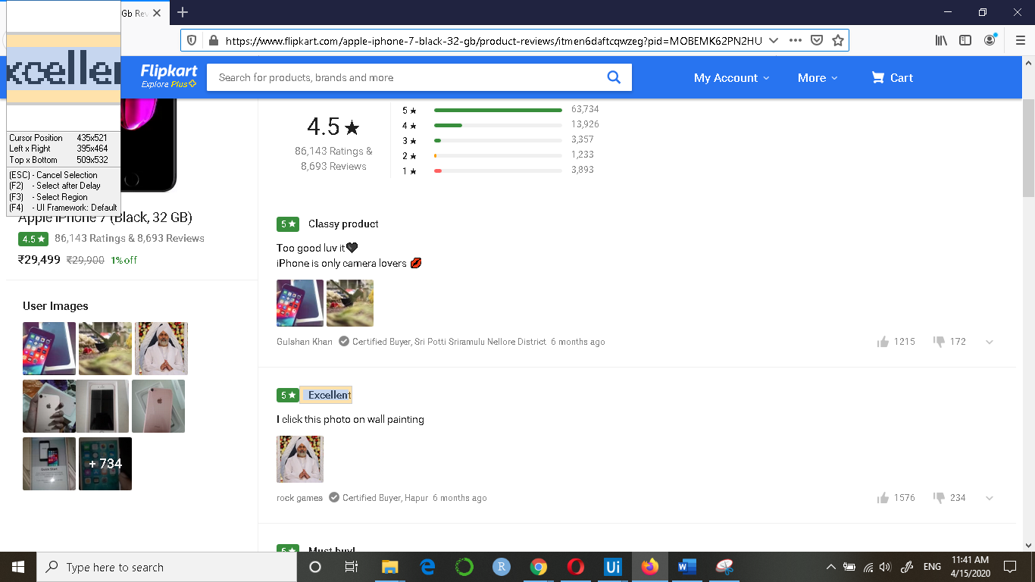

1. Give the column name as ‘Review_Title’ and click on Next

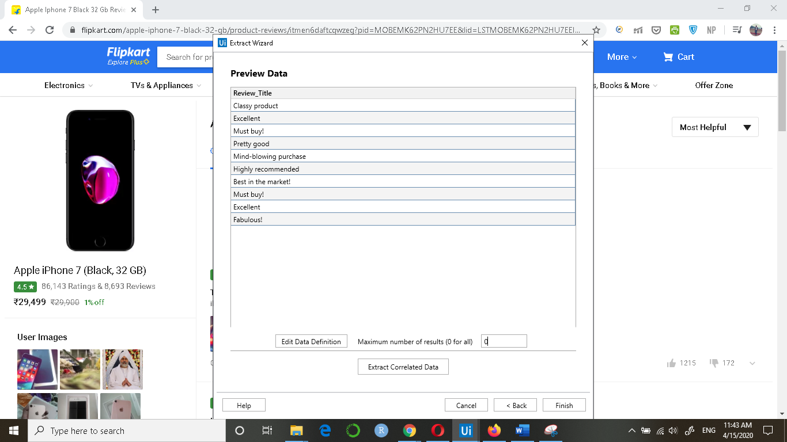

1. Now click on ‘Extract Correlated Data’ and extract the review text

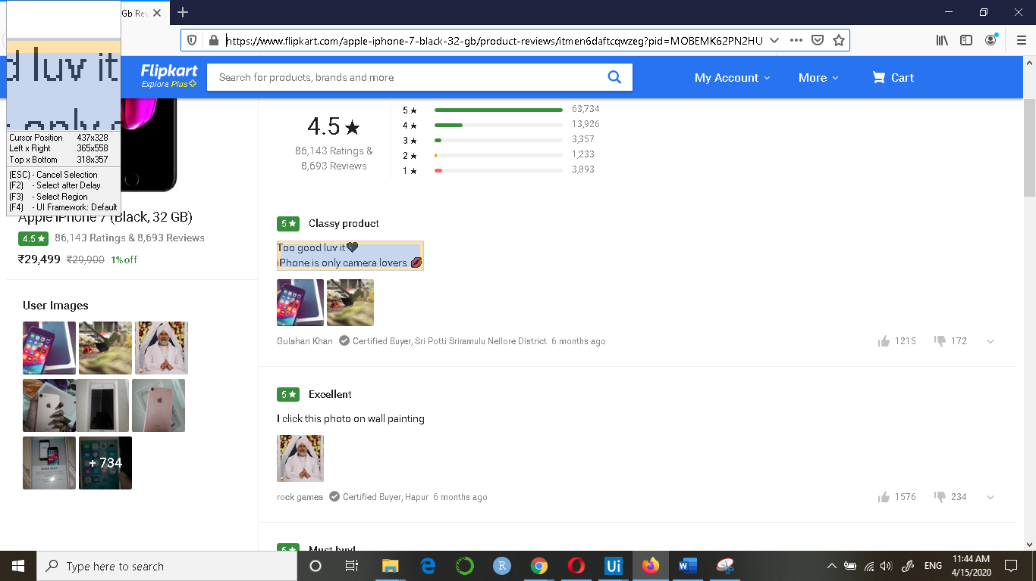

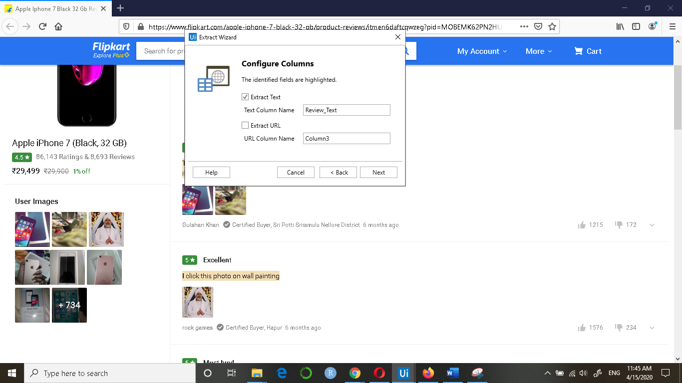

1. Repeat the steps above for Review Ratings, Date, Upvote and Downvote.

Review_Rating:

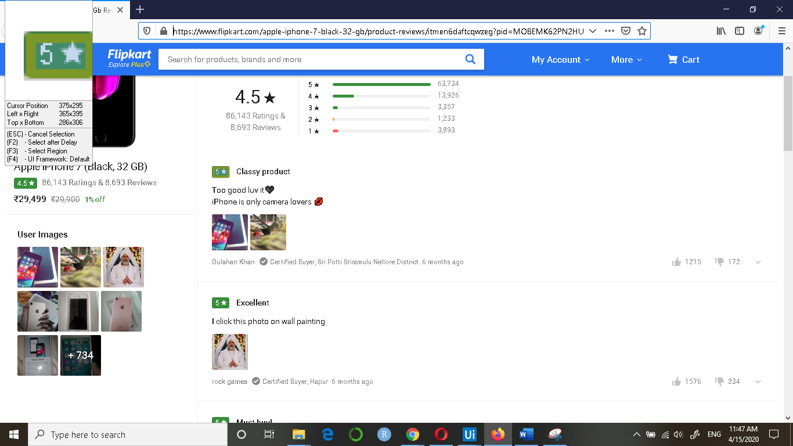

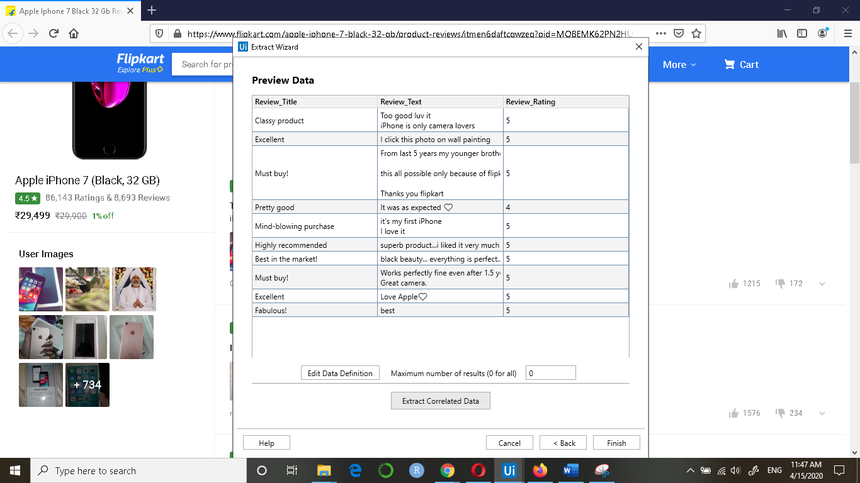

Review_Date:

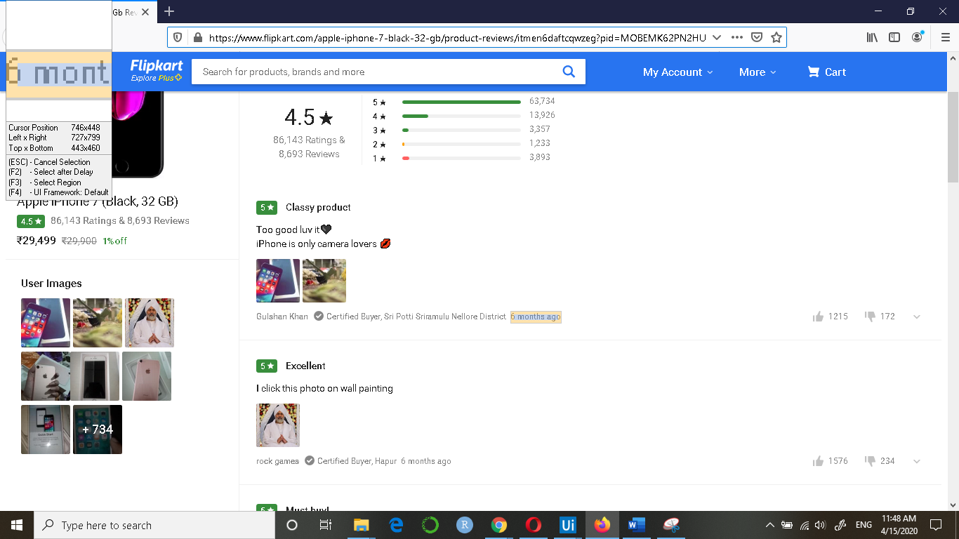

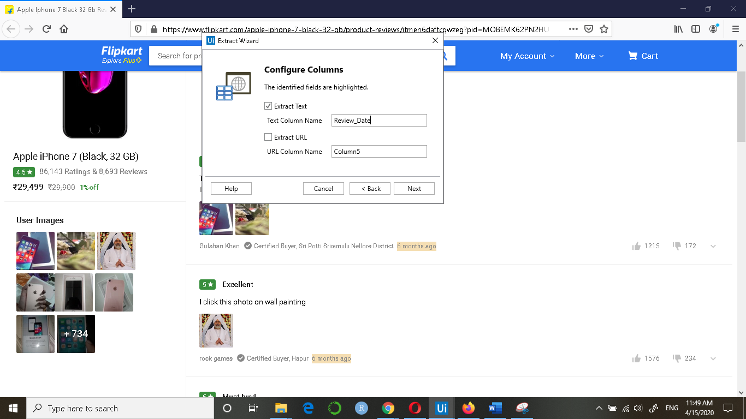

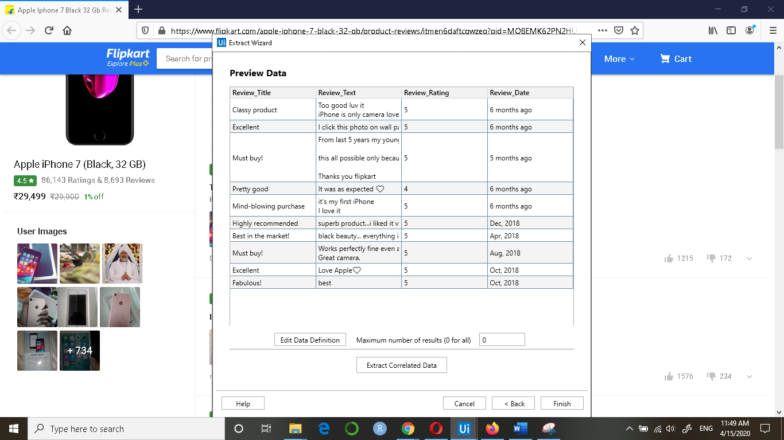

Upvote:

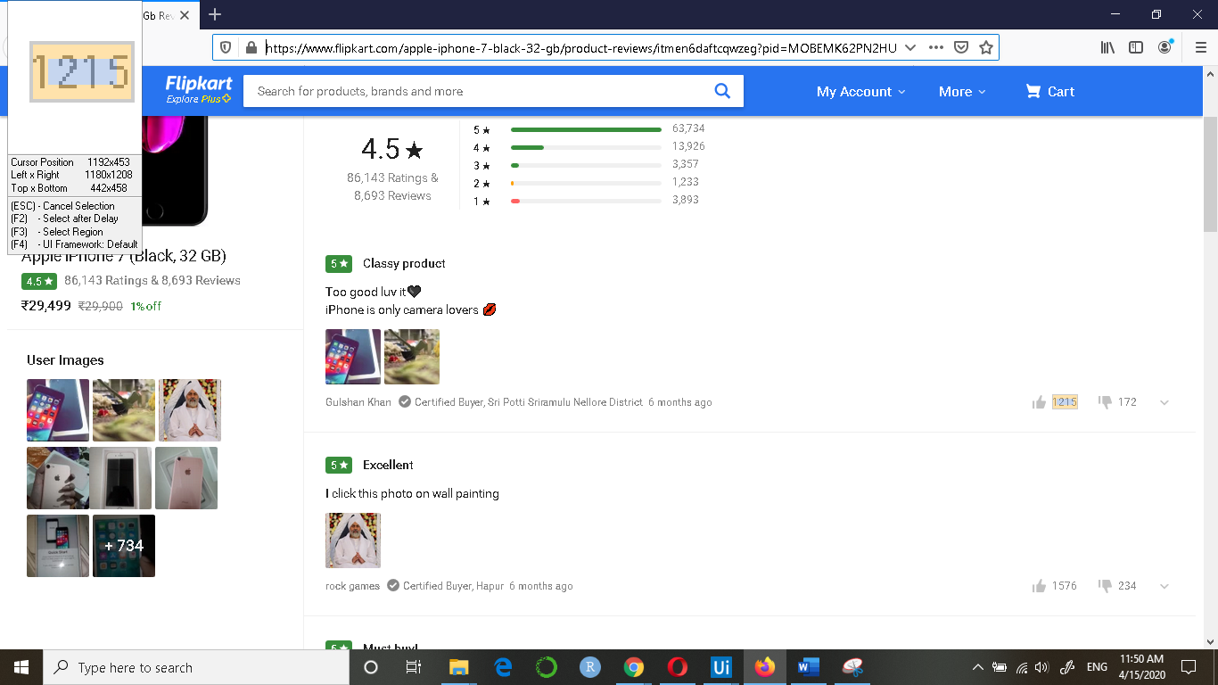

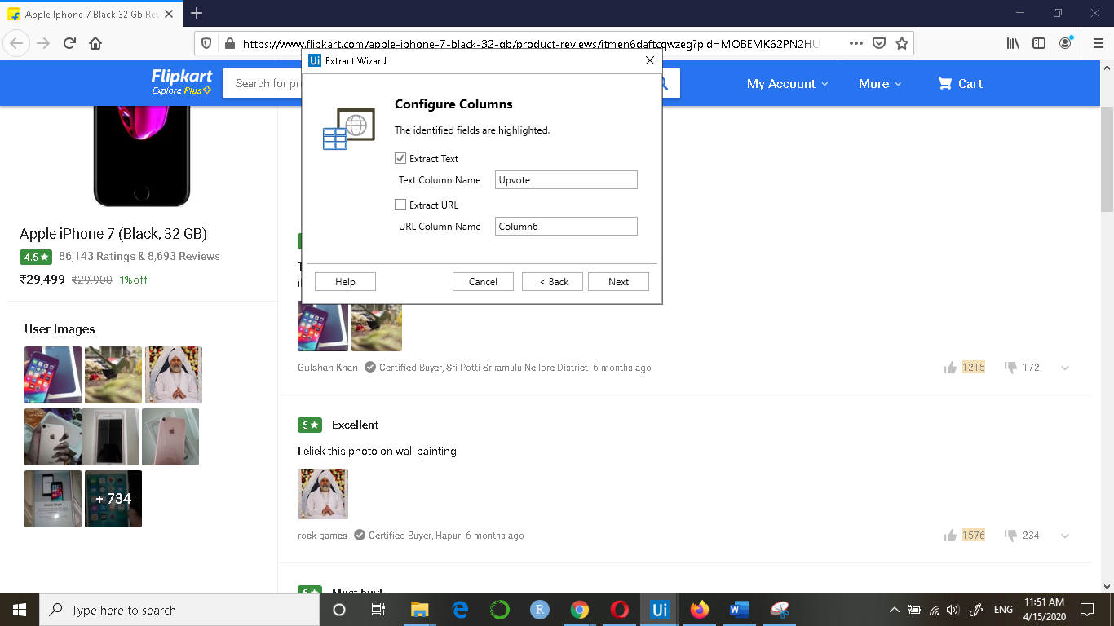

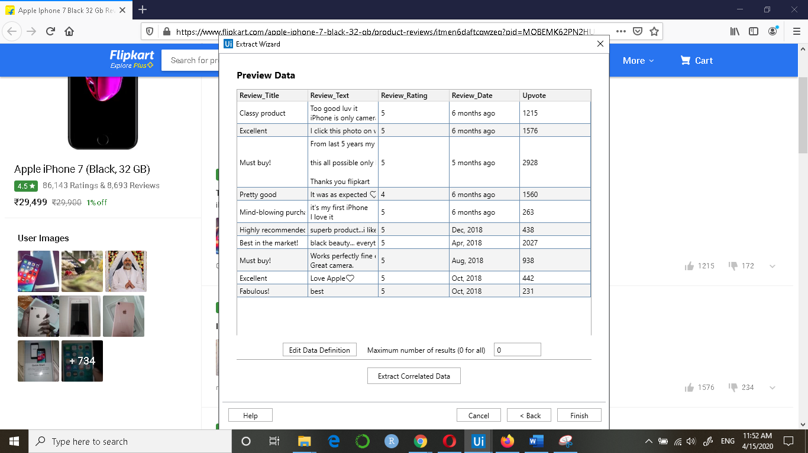

Downvote:

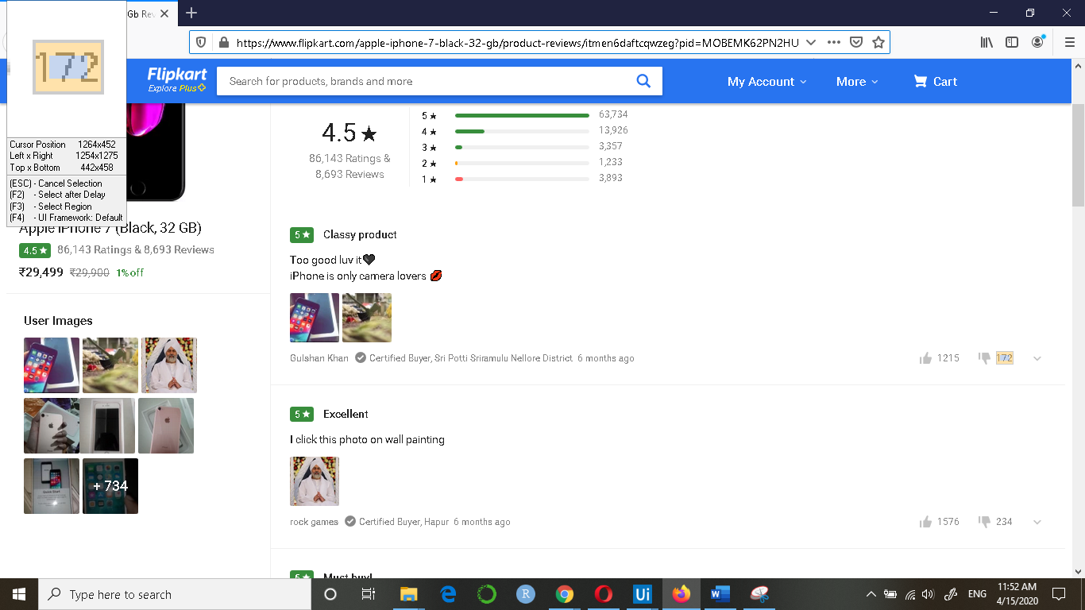

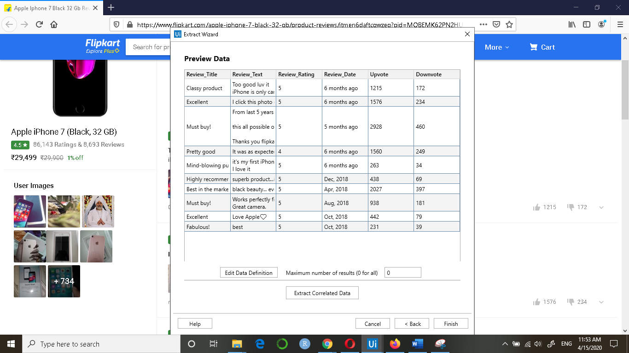

1. Once the extraction of the required fields is done, click in Finish. You will get the following dialog box:

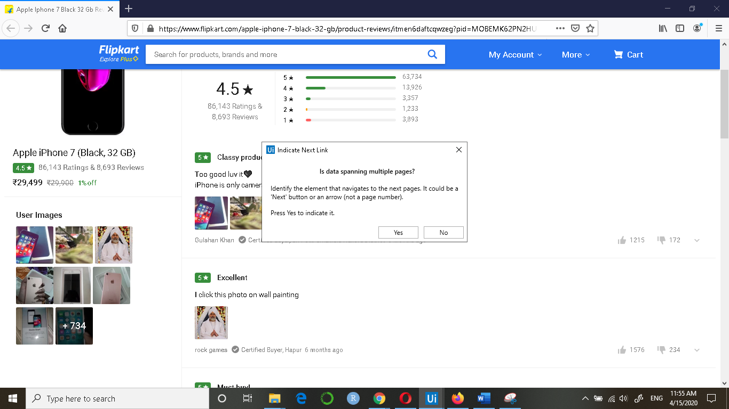

1. Click on Yes and then press F2 which will give 5 seconds to scroll down and then click on ‘NEXT’ button at the bottom

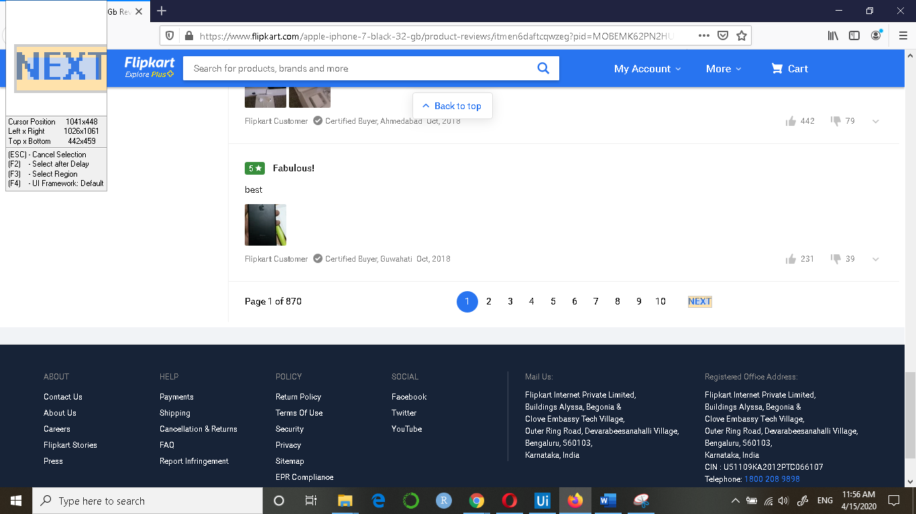

1. Once the above step is complete, you will be redirected to the following screen:

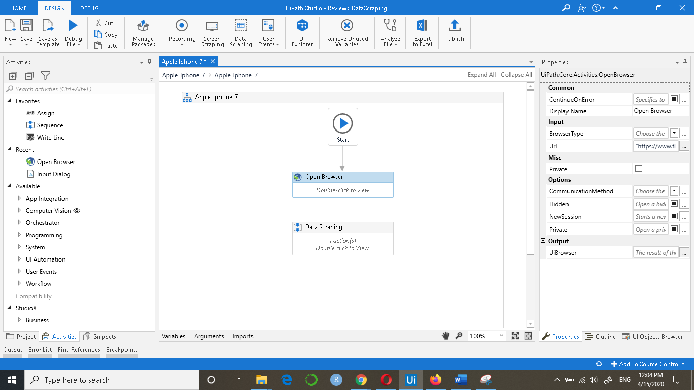

1. Connect the Open Browser and Data Scraping dialog boxes

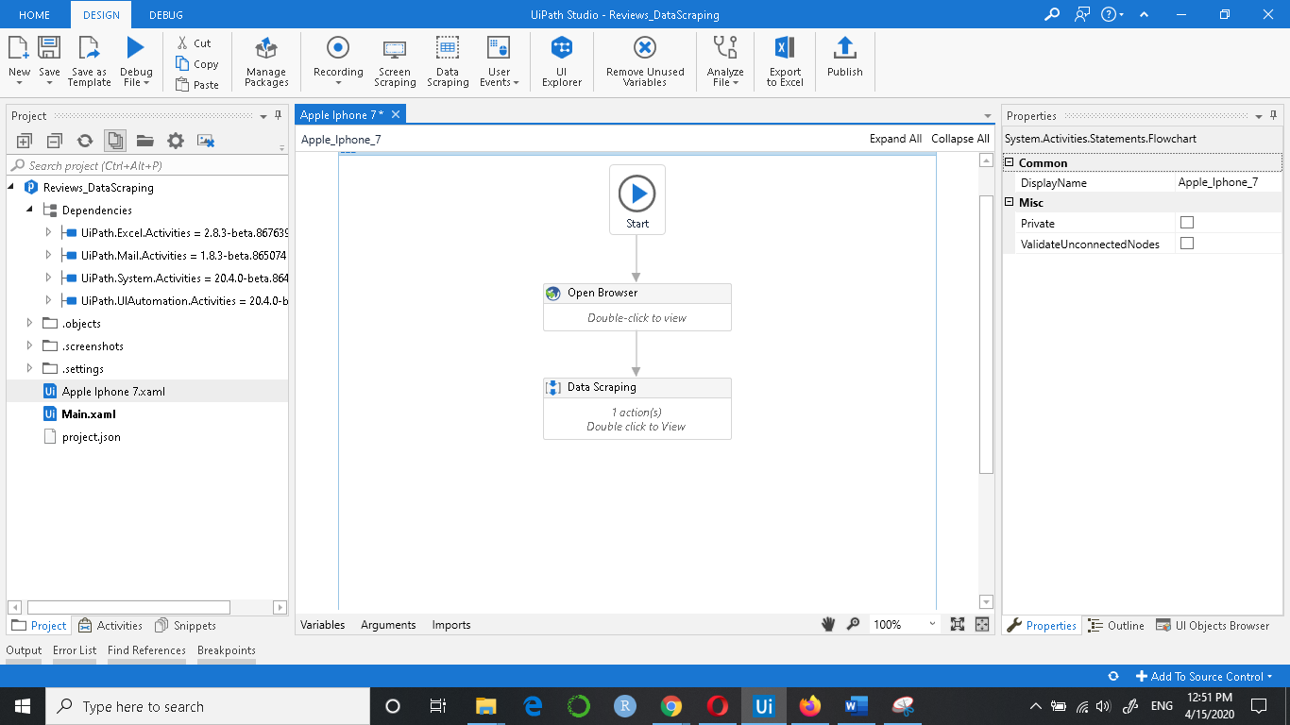

1. Search for ‘Write CSV’ in the search box and drag and drop below Data Scraping

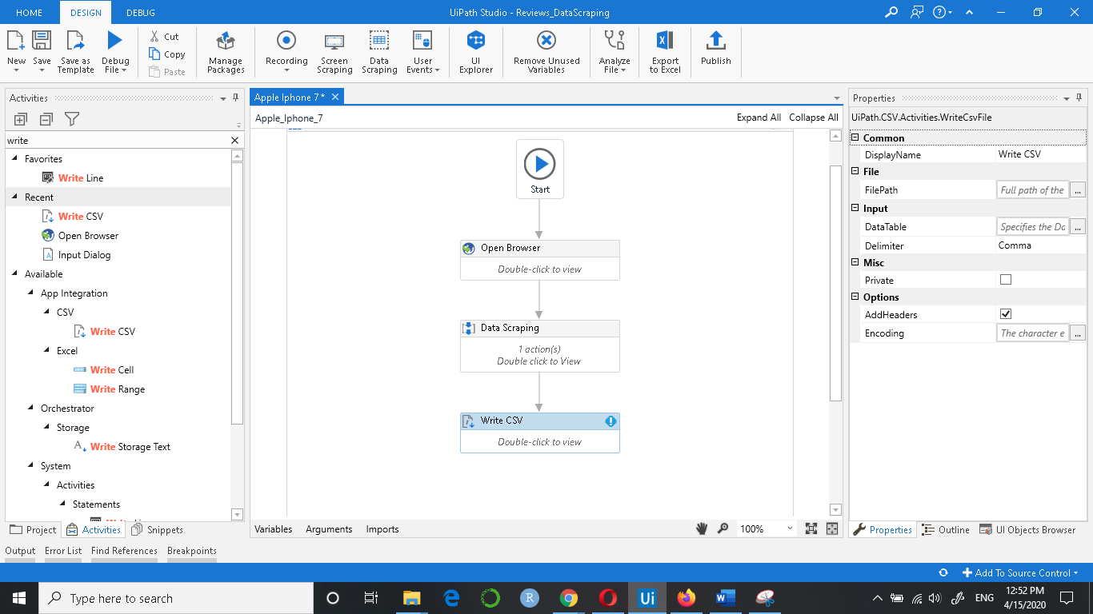

Double click on the Write CSV dialog box

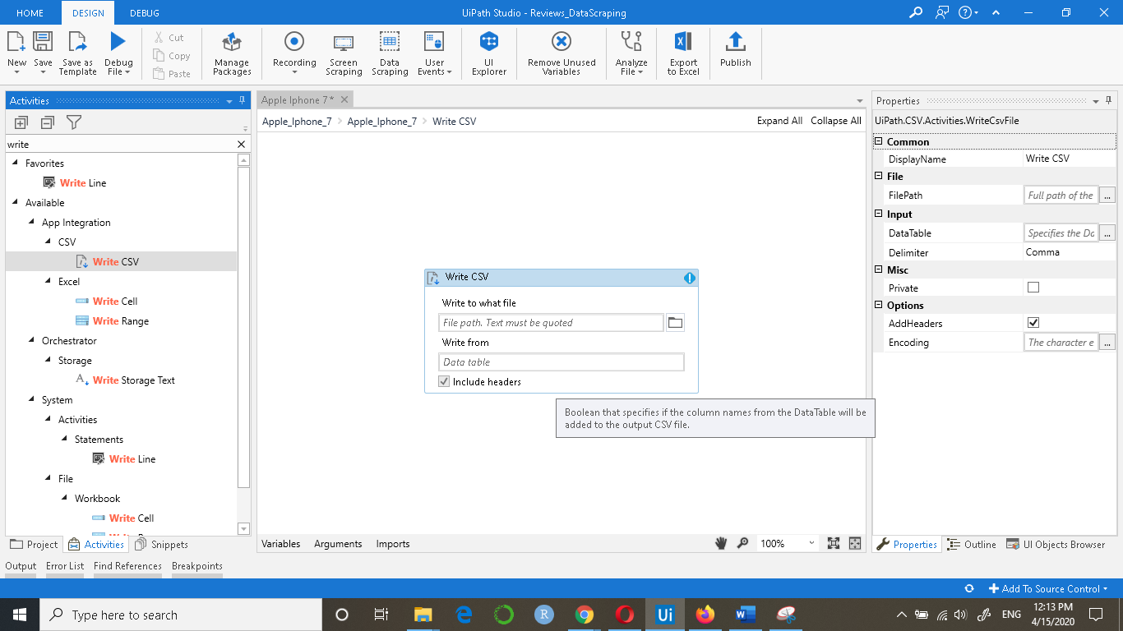

Enter the file path where you want to save the CSV file

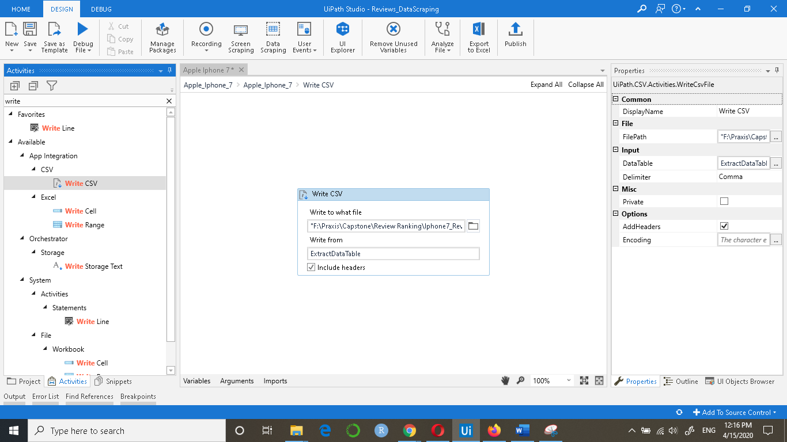

1. Now to run the file, click on the Debug File dropdown and select Run File:

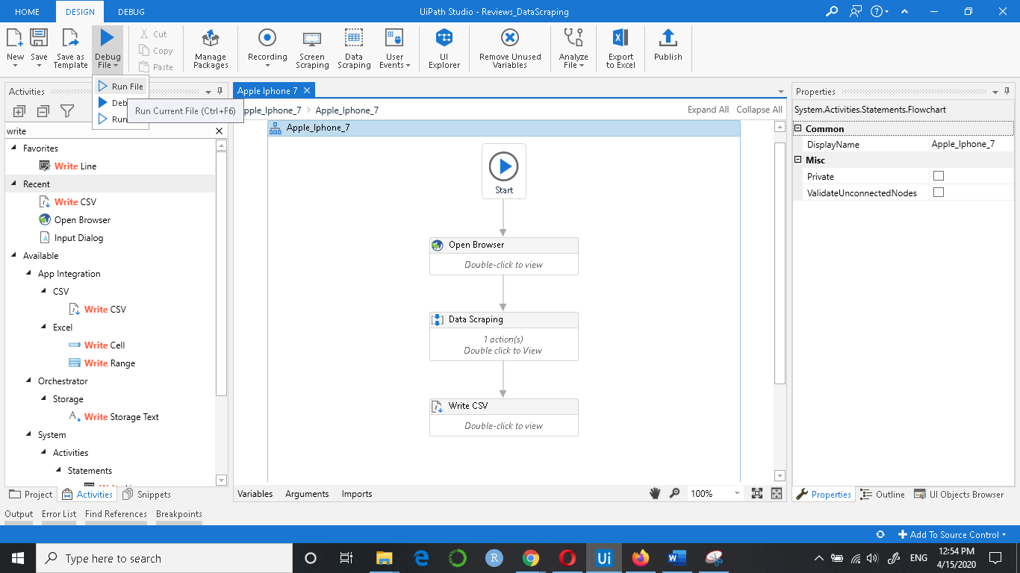

1. You will get the following csv file of the reviews:

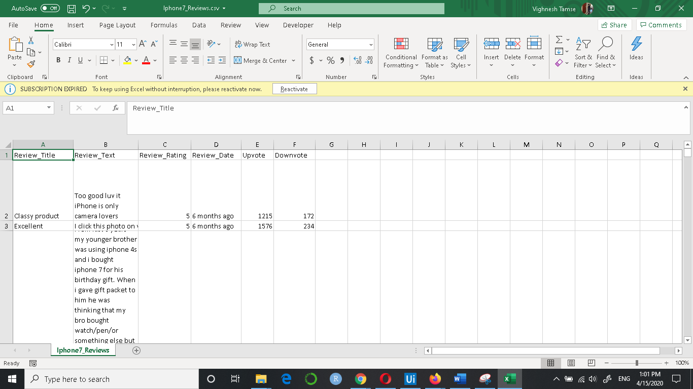

If the reviews are less, you can give the url of the page where the reviews were stopped in the Open Browser dialog box and again run the file.